OBJECT DETECTION BY ULTRASONIC MEANS

ABSTRACT

The project is designed to demonstrate detection of any object ahead of the ultrasonic transducer. It can be used for applications like security area monitoring and wild life photography etc.
This ultrasonic detector consists of two parts: an emitter, which produces a 40 kHz sound wave; and a detector, which detects this 40 kHz sound wave and sends the signal back to the microcontroller. The ultrasonic module is interfaced to the microcontroller of PIC family. Whenever any object approaches near the ultrasonic module, the signal transmitted the transmitter is reflected by this object and is received by the module. When the microcontroller receives the signal from ultrasonic receiver it actuates the output to take the appropriate action. An LCD is interfaced to the microcontroller for displaying the status of the module like whether the object is detected or not.
Further the project can be enhanced by interfacing a GSM modem to the project so that, when the object is detected then the controller sends an SMS to the user.

BLOCK DIAGRAM
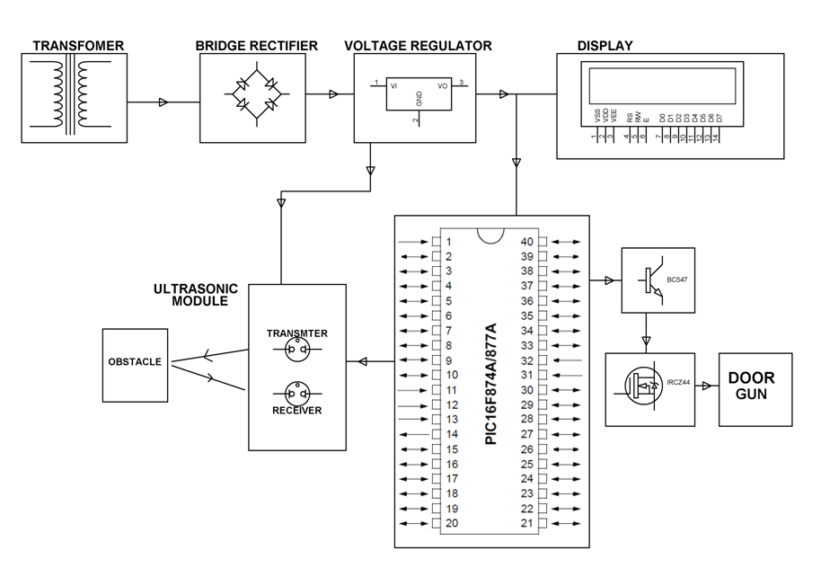

HARDWARE REQUIREMENTS:
PIC series Microcontroller, LCD, Ultrasonic module, LED, Transistor, Mosfet, Crystal, Transformer, Diodes, Voltage Regulator, Capacitors, Resistors, Magnetic Gun.

SOFTWARE REQUIREMENTS:

HI-TECH PICC Tool suite

Language: Embedded C or Assembly

